Source: https://algs4.cs.princeton.edu/12oop/
Object Oriented Programming: Programming in Java is largely based on building data types.
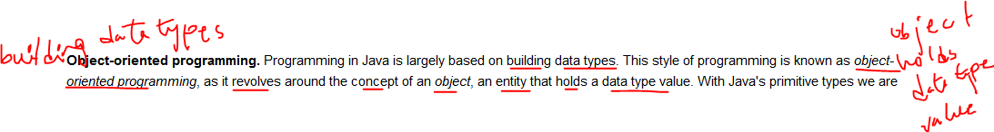
- Data Type: A data type is a set of values and a set of operations that can be done on those values.
- Abstract Data Type: An Abstract Data Type (ADT) is a data type whose internal representation is hidden from the client. The client only knows about the set of values the ADT can have and the set of operations that can be performed on those values.
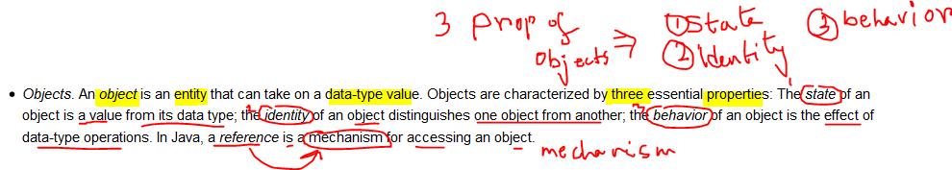
Properties of Object:
- State
- Identity
- Behavior
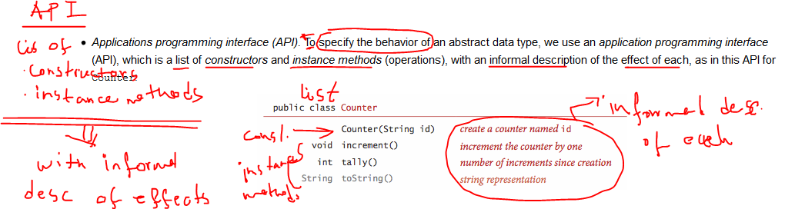
- Client: is a program that uses a data type.
- Implementation: is the code that implements the data type specified by the API
